Module 1: API Layer (Real time weather data)
Data Structure:
Weather -> struct (Attributes: windspeed, temperature, alerts)
We will only display temperature directly and the windspeed and alerts will be used to calculate the obstacles.

Module 2: Environment Representation Module
Data Structure:
Map -> 2D grid using SFML
There will be a side bar for the info of:
- Drone (fuel percentage) health
- Timestamp
- Current temperature, wind speed
- Remaining targets and missiles

Module 3: Target Locations Module

Data Structure:
Bases -> struct (Attributes: name, coordinates, priority) // priority will be the critical points stored against each base.
City -> struct (Attributes: name, vector<Base> base)

Module 4: Drone State and Resource Module

Stacks using Linked Lists
Visualization:
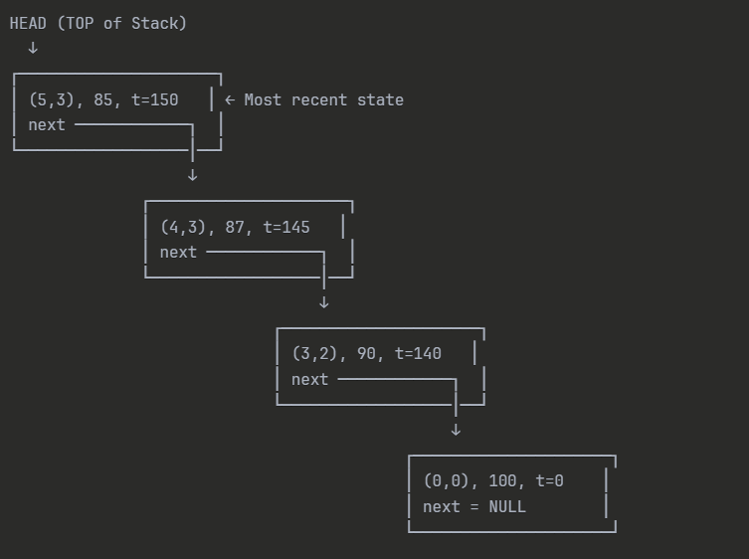
Module 5: Target & Mission Management Module
Bases: Weighted graph, Array of objects jis mai bases ka name, coordinates aur priorities store hongy
Fuel level ki 2D array bnegi.
Visualization:
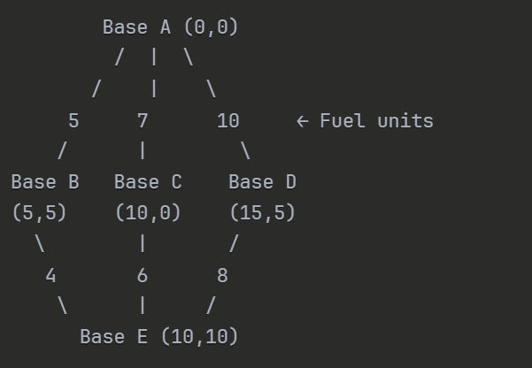

When user selects the target locations, graph is converted into priority queue with priority (attribute in base struct)
If the target location does not have a direct link then we will use BFS to find the shortest path to the target location.

Module 6: Analysis Report
Mission summary:
- Total missions assigned
- Mission completed/pending (status)
Resource consumption:
- Starting fuel
- Fuel consumed & remaining
Timeline:
- Order of execution, mission sequence

